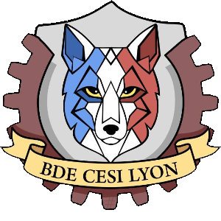

Corporate identity and style guide

Table des matières

1. Logotype : 3

2. Color univers: 4

3. Typography 5

Yanone Kaffeesatz Light 5

Yanone Kaffeesatz Regular 5

Yanone Kaffeesatz Bold 5

PT Sans Caption Web Regular 5

PT Sans Caption Web Bold 5

# Logotype :

The BDE logo represent a wolf whit the color of the engineering formation of the CESI (blue for EI and red for EXIA). The wolf symbolises the team spirit, intelligence, and sociability.

This logo must be used on a plain light background or a soft degraded. It does not need a protection zone, that means a white area around the logo.

The logo have 5 différents color:

Light yellow: Brown: Grey:

Hex: #ffdf90 Hex: #905f62 Hex: #a5a5a5

RGB: rgb(255, 223, 144) RGB: rgb(144, 95, 98) RGB: rgb(165,165, 165)

Light blue: Light red:

Hex: #6e9fee Hex: #cb625c

RGB: rgb(110, 159, 238) RGB: rgb(203, 98, 92)

We also used the Exia and EI logo:

 

# Color univers:

The principal colors are the two color of the EXIA CESI logo and color that are near them, they can be used for the Titles or current text:

Red: Grey:

Hex: #c2242a Hex: #bebebe

RGB: rgb(194, 36, 42) RGB: rgb(190, 190, 190)

Black: Red:

Hex: #000000 Hex:#bb233c

RGB: rgb(0, 0, 0) RGB: rgb(187,35,60)

Red

Hex:#bb233c

RGB: rgb(187,35,60)

# Typography

We used 3 different typographies:

## Yanone Kaffeesatz Light

abcdefghijklmnopqrstuvwxyz

ABCDEFGHIJKLMNOPQRSTUVWXYZ 123456789

## Yanone Kaffeesatz Regular

abcdefghijklmnopqrstuvwxy

ABCDEFGHIJKLMNOPQRSTUVWXYZ 123456789

## Yanone Kaffeesatz Bold

**abcdefghijklmnopqrstuvwxy**

**ABCDEFGHIJKLMNOPQRSTUVWXYZ 123456789**

## PT Sans Caption Web Regular

abcdefghijklmnopqrstuvwxyz

ABCDEFGHIJKLMNOPQRSTUVWXYZ 123456789

## PT Sans Caption Web Bold

**abcdefghijklmnopqrstuvwxyz**

**ABCDEFGHIJKLMNOPQRSTUVWXYZ 123456789**